**EMPLOYEE MANAGEMENT SYSTEM**

**PROJECT REPORT**

**18CSC202J/ 18AIC203J - OBJECT ORIENTED DESIGN AND PROGRAMMING LABORATORY**

**(2018 Regulation)**

**II Year/ III Semester**

**Academic Year: 2022 -2023**

By

**SRI KRISHNA ADITYA GARIMELLA (RA2111003010955)**

**ROCHIT MEHROTRA (RA2111003010918)**

Under the guidance of

**Dr. Manoj Kumar Rana**

**Research Assistant Professor**

**Department of Computing Technologies**



**FACULTY OF ENGINEERING AND TECHNOLOGY**

**SCHOOL OF COMPUTING**

**SRM INSTITUTE OF SCIENCE AND TECHNOLOGY**

**Kattankulathur, Kancheepuram**

**NOVEMBER 2022**

**BONAFIDE**

This is to certify that **18CSC202J - OBJECT ORIENTED DESIGN AND PROGRAMMING LABORATORY project report** titled

“**EMPLOYEE MANAGEMENT SYSTEM”** is the bonafide work of

**SRIKRISHNAADITYAGARIMELLA(RA2111003010955)**

**ROCHITMEHROTRA(RA2111003010918)**

who undertook the task of completing the project within the allotted time.

**Signature of the Guide** **Signature of the II Year Academic Advisor**

Dr. S. Amudha -------------------------

**Assistant Professor** **Professor and Head**

Department of CINTEL, Department of CINTEL

SRM Institute of Science and Technology SRM Institute of Science and Technology

**About the course:-**

18CSC202J/ 8AIC203J - Object Oriented Design and Programming are 4 credit courses with **L T P C as 3-0-2-4** (Tutorial modified as Practical from 2018 Curriculum onwards)

**Objectives:**

The student should be made to:

* Learn the basics of OOP concepts in C++
* Learn the basics of OOP analysis and design skills.
* Be exposed to the UML design diagrams.
* Be familiar with the various testing techniques

**Course Learning Rationale (CLR): The purpose of learning this course is to:**

1. Utilize class and build domain model for real-time programs
2. Utilize method overloading and operator overloading for real-time application development programs
3. Utilize inline, friend and virtual functions and create application development programs
4. Utilize exceptional handling and collections for real-time object-oriented programming applications
5. Construct UML component diagram and deployment diagram for design of applications
6. Create programs using object-oriented approach and design methodologies for real-time application development

**Course Learning Outcomes (CLO): At the end of this course, learners will be able to:**

1. Identify the class and build domain model
2. Construct programs using method overloading and operator overloading
3. Create programs using inline, friend and virtual functions, construct programs using

standard templates

1. Construct programs using exceptional handling and collections
2. Create UML component diagram and deployment diagram
3. Create programs using object oriented approach and design methodologies

**Table 1: Rubrics for Laboratory Exercises**

(Internal Mark Splitup:- As per Curriculum)

| **CLAP-1** | 5=(2(E-lab Completion) + 2(Simple Exercises)( from CodeZinger, and any other coding platform) + 1(HackerRank/Code chef/LeetCode Weekend Challenge) | Elab test |
| --- | --- | --- |
| **CLAP-2** | 7.5=(2.0(E-lab Completion)+  2.0 (Simple Exercises)( from CodeZinger, and any other coding platform) + 3.5 (HackerRank/Code chef/LeetCode Weekend Challenge) | Elab test |
| **CLAP-3** | 7.5=(2.0(E-lab Completion(80 Pgms)+  2.0 (Simple Exercises)( from CodeZinger, and any other coding platform) + 3.5 (HackerRank/Code chef/LeetCode Weekend Challenge) | **2 Mark -** E-lab Completion **80 Program** Completion from 10 Session (Each session min 8 program)  **2 Mark -** Code to UML conversion GCR Exercises  **3.5 Mark - Hacker Rank** Coding challenge completion |
| **CLAP-4** | 5= 3 ( Model Practical) + 2( Oral Viva) | * **3 Mark** – Model Test * **2 Mark** – Oral Viva |
| **Total** | 25 |  |

**COURSE ASSESSMENT PLAN FOR OODP LAB**

| **S.No** | **List of Experiments** | **Course Learning Outcomes (CLO)** | **Blooms Level** | **PI** | **No of Programs in each session** |
| --- | --- | --- | --- | --- | --- |
| 1. | Implementation of I/O Operations in C++ | CLO-1 | Understand | 2.8.1 | 10 |
| 2. | Implementation of Classes and Objects in C++ | CLO-1 | Apply | 2.6.1 | 10 |
| 3, | To develop a problem statement. 1. From the problem statement, Identify Use Cases and develop the Use Case model. 2. From the problem statement, Identify the conceptual classes and develop a domain model with a UML Class diagram. | CLO-1 | Analysis | 4.6.1 | Mini Project Given |
| 4. | Implementation of Constructor Overloading and Method Overloading in C++ | CLO-2 | Apply | 2.6.1 | 10 |
| 5. | Implementation of Operator Overloading in C++ | CLO-2 | Apply | 2.6.1 | 10 |
| 6. | Using the identified scenarios, find the interaction between objects and represent them using UML Sequence diagrams and Collaboration diagrams | CLO-2 | Analysis | 4.6.1 | Mini Project Given |
| 7. | Implementation of Inheritance concepts in C++ | CLO-3 | Apply | 2.6.1 | 10 |
| 8. | Implementation of Virtual function & interface concepts in C++ | CLO-3 | Apply | 2.6.1 | 10 |
| 9. | Using the identified scenarios in your project, draw relevant state charts and activity diagrams. | CLO-3 | Analysis | 4.6.1 | Mini Project Given |
| 10. | Implementation of Templates in C++ | CLO-3 | Apply | 2.6.1 | 10 |
| 11. | Implementation of Exception of Handling in C++ | CLO-4 | Apply | 2.6.1 | 10 |
| 12. | Identify the User Interface, Domain objects, and Technical Services. Draw the partial layered, logical architecture diagram with UML package diagram notation such as Component Diagram, Deployment Diagram. | CLO-5 | Analysis | 4.6.1 | Mini Project Given |
| 13. | Implementation of STL Containers in C++ | CLO-6 | Apply | 2.6.1 | 10 |
| 14. | Implementation of STL associate containers and algorithms in C++ | CLO-6 | Apply | 2.6.1 | 10 |
| 15. | Implementation of Streams and File Handling in C++ | CLO-6 | Apply | 2.6.1 | 10 |

**LIST OF EXPERIMNENTS FOR UML DESIGN AND MODELLING:**

**To develop a mini-project by following the exercises listed below.**

1. To develop a problem statement.

2. Identify Use Cases and develop the Use Case model.

3. Identify the conceptual classes and develop a domain model with UML Class diagram.

4. Using the identified scenarios, find the interaction between objects and represent them

using UML Sequence diagrams.

5. Draw relevant state charts and activity diagrams.

6. Identify the User Interface, Domain objects, and Technical services. Draw the partial

layered, logical architecture diagram with UML package diagram notation.

**Suggested Software Tools for UML:**

StarUML, Rational Suite, Argo UML (or) equivalent, Eclipse IDE and Junit

**ABSTRACT**

### Analyze

The first objective is to analyze the factors affecting the effectiveness of a company’s HR management. Also, it is important to analyze the reasons why people leave their companies, and why they are not productive.

The information would enable the company to implement ways of improving its services. For example, companies can use this information to monitor their employees’ performance and how they are [achieving their goals](https://www.worker-management.com/job-role-of-an-employee-experience-program-manager/).

### Plan

The second objective is to plan for the improvement of the human resources management in an organization. Any organization must have a system that will enable them to plan for the training, development, and career planning of the employees.

It is by developing a career path, setting goals, and reviewing them with employees. Also, the organization.

### Implement

The third objective is to implement a system that will help improve human resource management in an organization.

An organization needs to have a system that will help it to implement these improvements. For example, an organization could use an employee management system to track the performance of their employees and how they are achieving their goals.

### Track

The fourth objective is to track the data in the system. Since it is a management system, it is important to track all activities that are being done in the organization.

A company should be able to track employees’ work hours, attendance, and [overall performance](https://www.worker-management.com/what-is-the-manager-employee-experience-job-description/). This will enable the company to identify the strengths and weaknesses of each employee.

### Document

The fifth objective is to document the information in an organization. An employee management system should be able to store all the information collected from the employees. This information can be used in case of any disputes that may arise between employees and their employers.

For example, if an employee has issues with their employer, they can use this information as evidence in court. Also, employers need to have proper documentation of the employees who leave the company.

### Control

The sixth objective is to control the system. An organization should have the ability to control all activities that are going on in the system. This will enable the organization to identify any changes that are needed in the system. Also, an organization should keep a close eye on their employees’ activities.

### Report To Managers And Shareholders

The seventh objective is to report to managers and shareholders. An organization needs to have a system that will identify the progress of each employee and how well they are doing their job.

For example, an organization needs to have information about how their employees are performing; this will enable them to [give rewards](https://www.researchgate.net/publication/347615091_Employee_Management_System) and bonuses to those who are performing well.

**MODULE DESCRIPTION**

The primary concern of this Employee Management System project is to make a system which will help any organization to maintain the employee’s information. The user can easily operate this system as it will provide the user-friendly interface. The Employee Management System will be based on the internet and can be accessed from anywhere. This project will make the entire management system automate to increase the speed of the management system, further it will reduce the cost of management by reducing the number of persons required to maintain any information. While the development of the system will be simple and allow for the expansion of the project in the future as per the requirement.

## Existing system

In the present Employee Management System of data management, some person maintains the data manually, which required a high amount of time as there are so many people work in the organization. The organization keeps the record of all the employees in the paper which is not a secure way of maintaining the data. As there is a high amount of register in which information is stored consume a lot of space in the organization while retrieving any information from that many files consume huge time and it is not an easy process.

## Proposed system

This Employee Management System project will help the organization with the management of the information of the employees. The system will centralize the management system and will provide different options through access to data will become accessible. The system will be based on the internet so that any user can use it from any place with ease. The Employee Management System software will make a report of each employee of the organization at the end of the month so that the organization will have information about the work of each employee. This Employee Management System will not only reduce the time but as well it will make the system efficient.

**Use case diagram with explanation**

The **UML use case diagram for employee management system** is used to show the processes involved when users invoke the software. It depicts the structure of the system behavior.

Additionally, the **diagram** consists of **processes**(use cases) and **users**or “actors”. It uses defined symbols to describe the overall flow of the system.

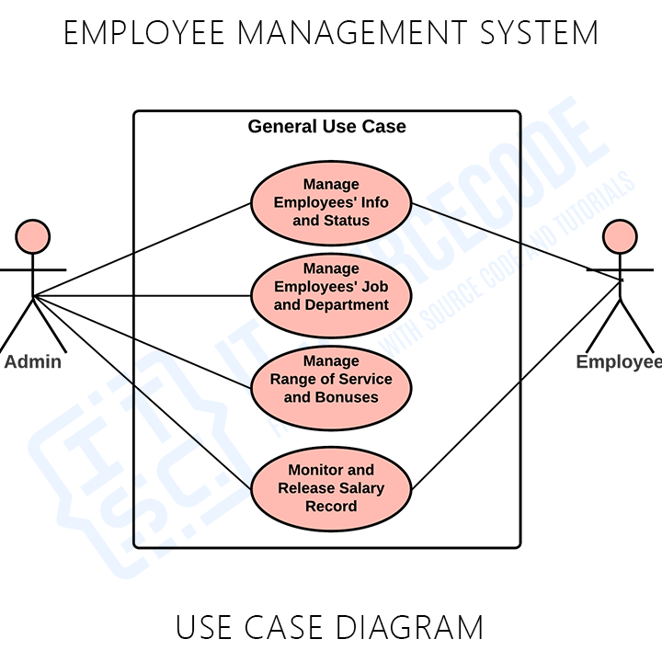

This is the process where the admin manages incentives and bonuses for employees. The information was based on the performance of the employees and their information. The system also saves important employee information and calculates fair salaries for them. One of the methods that contribute to the **employee management system development** is the UML use case diagram. It helps developers know the possible inputs that the project should process and perform.

Furthermore, you will find out the needed processes and connect them to the other UML Diagrams. The diagram is also applicable in modeling the software’s use cases (processes). It also captures the system’s flow from one process to the next.

**Class diagram with explanation**

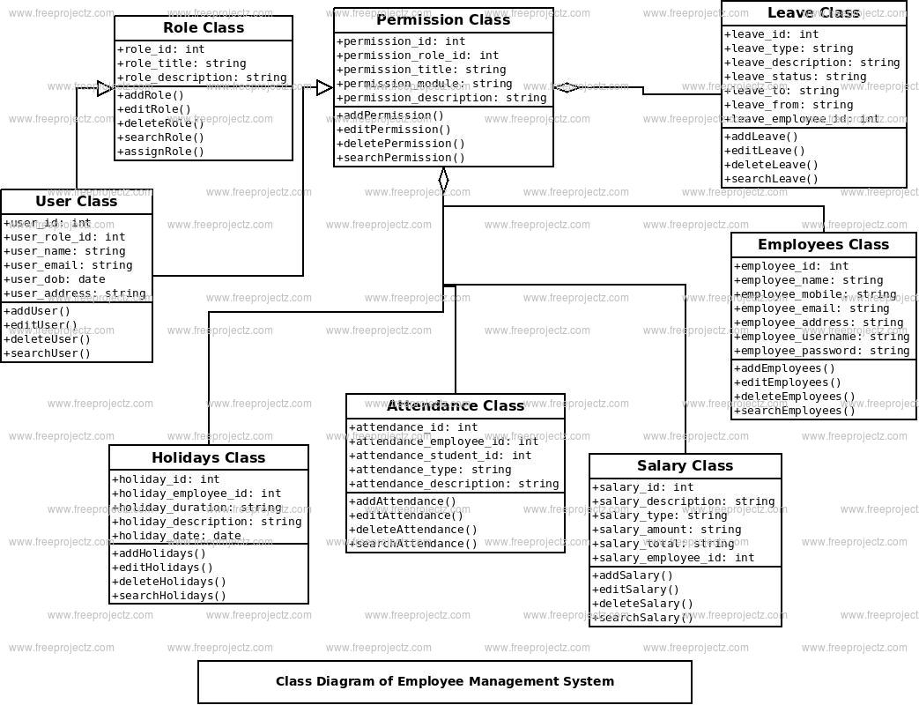

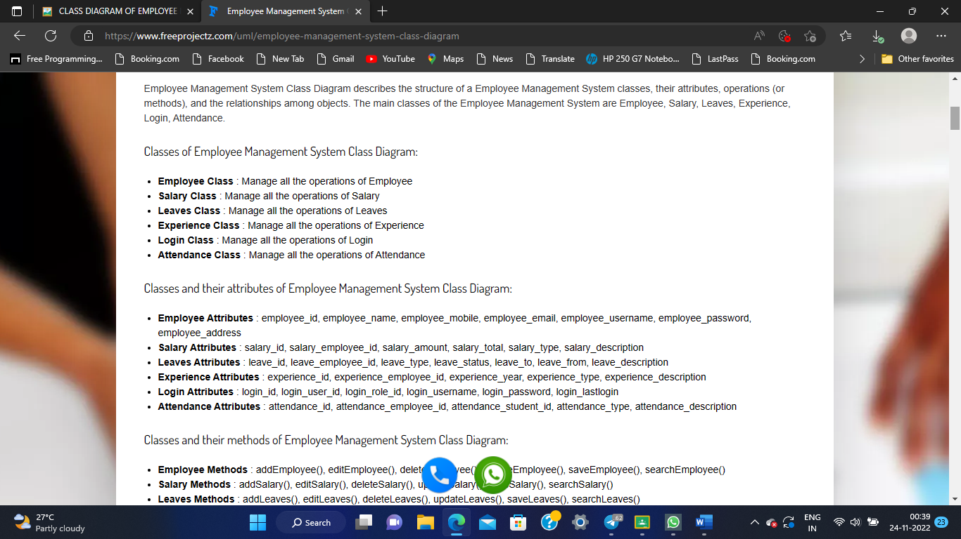

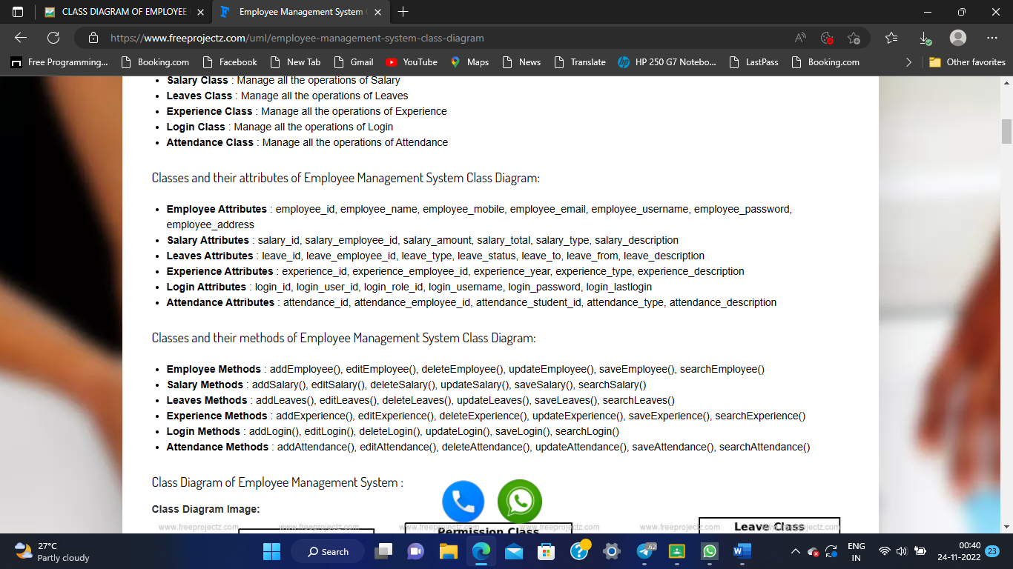

**Sequence diagram with explanation**

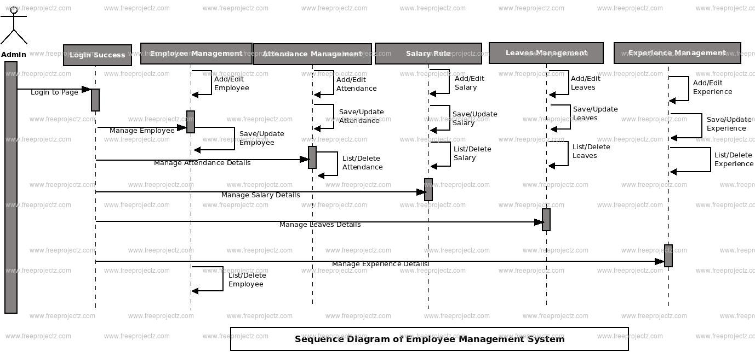

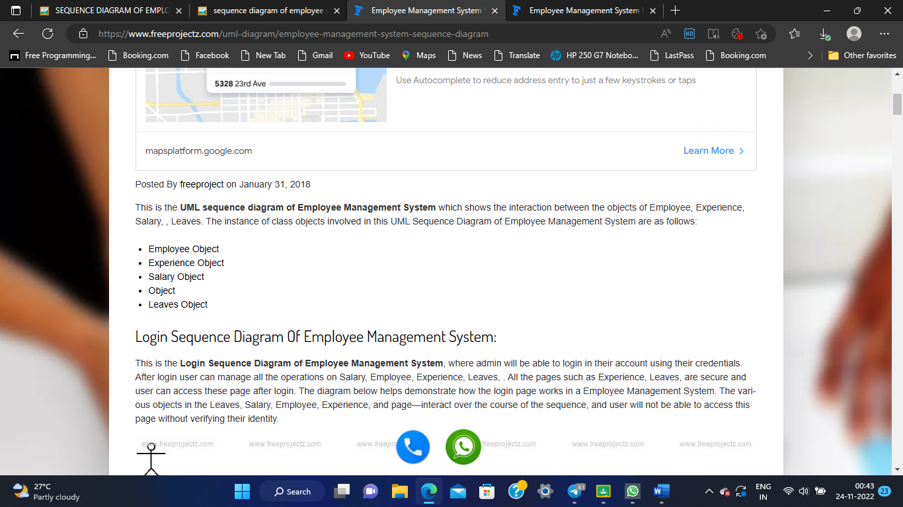

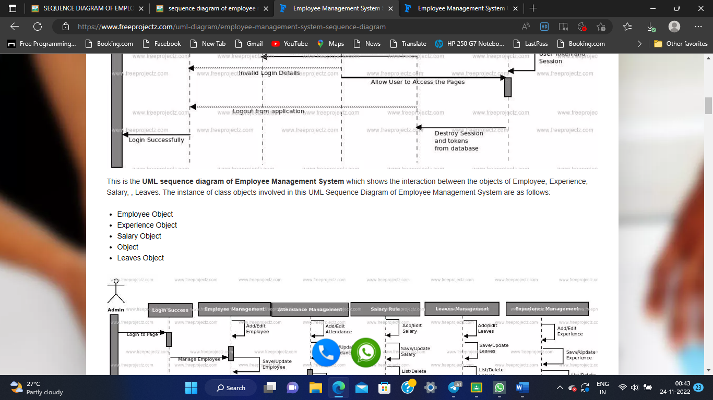

**Communication diagram with explanation**

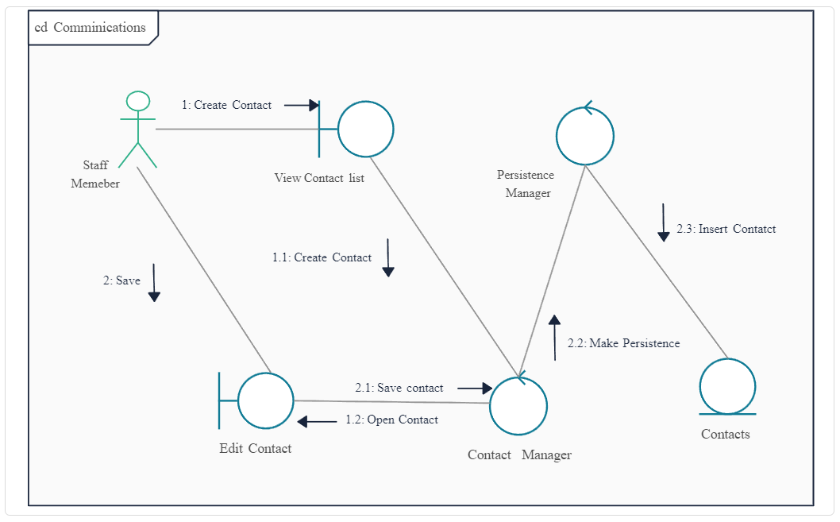

**State chart diagram with explanation**

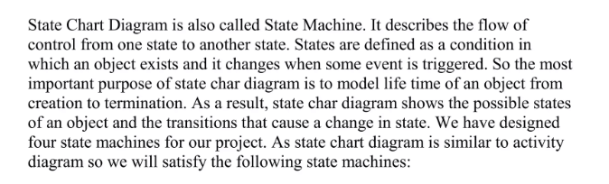

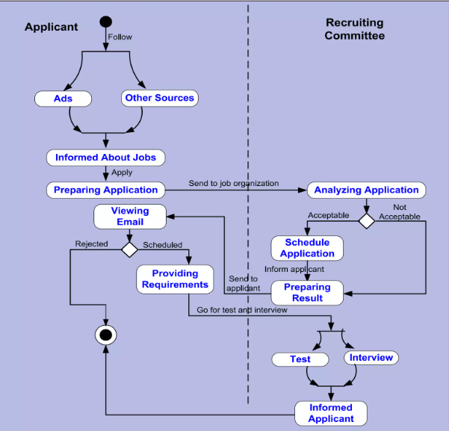

**Activity diagram with explanation**

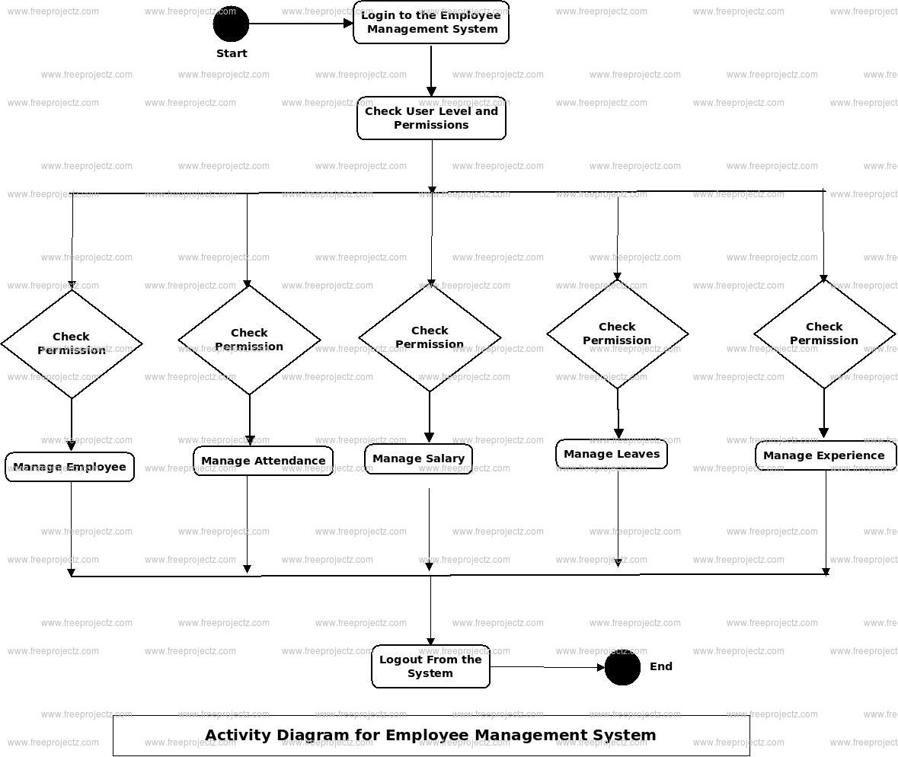

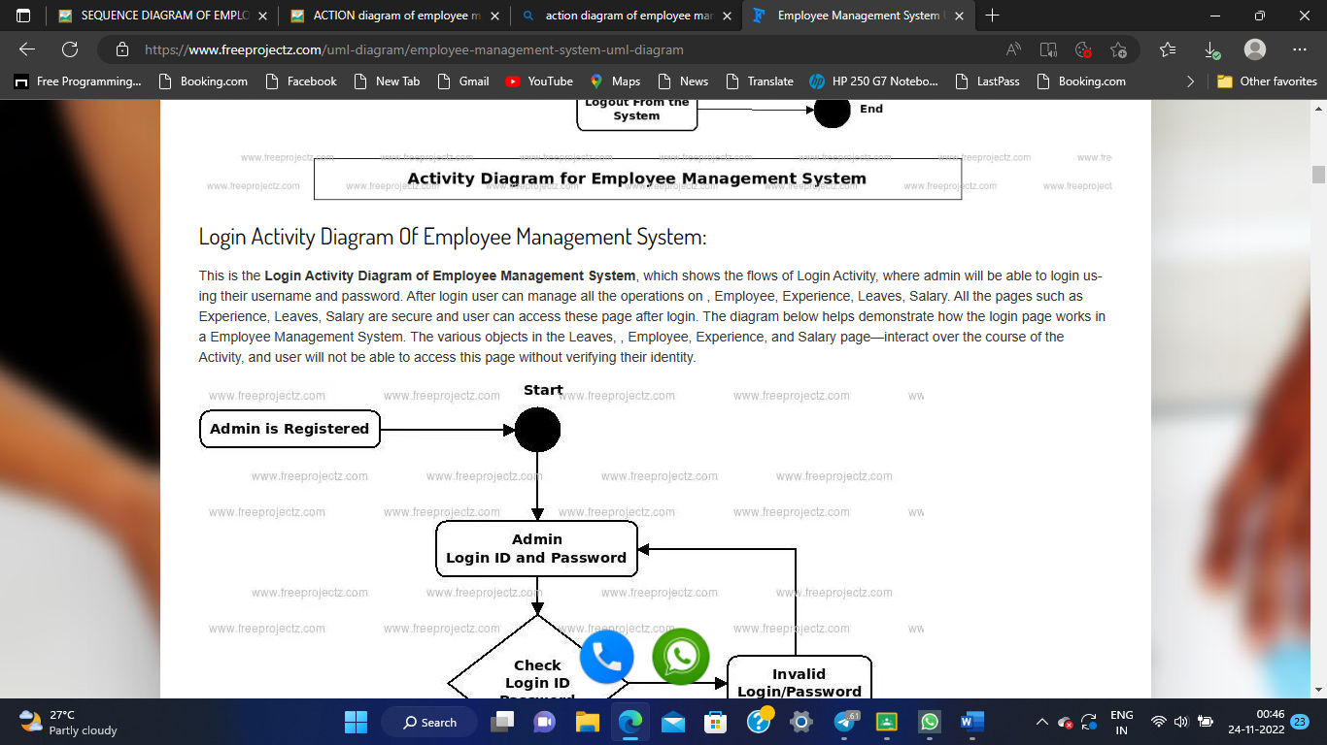

**Package diagram with Explanation**

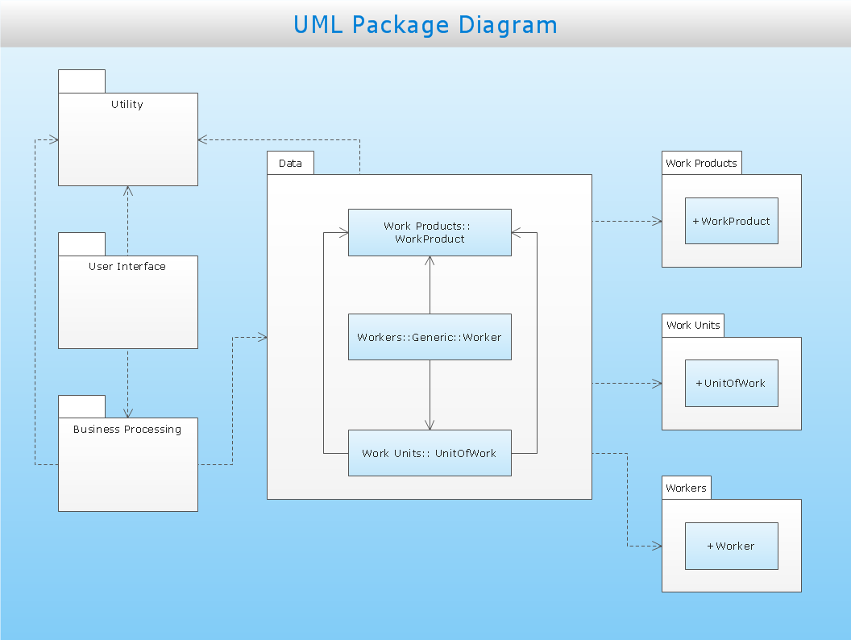

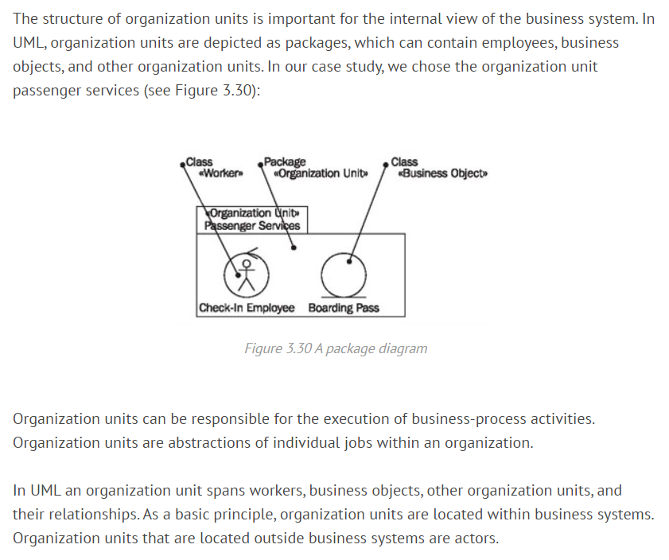

**Component diagram with explanation**

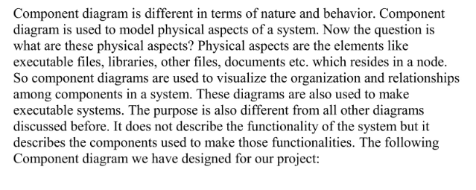

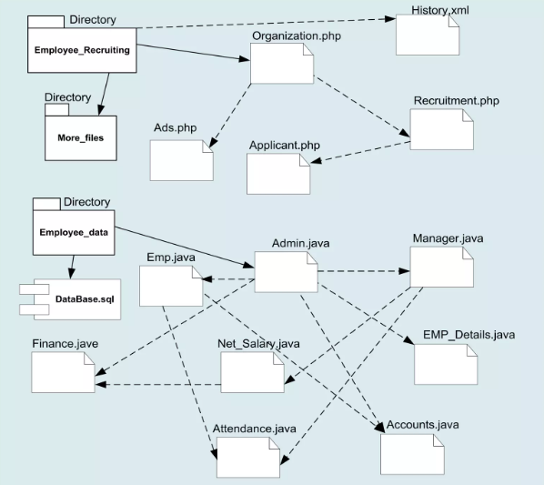

**Deployment diagram with explanation**

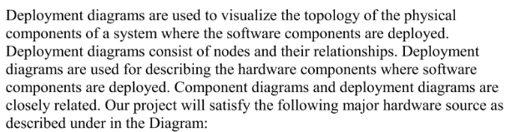

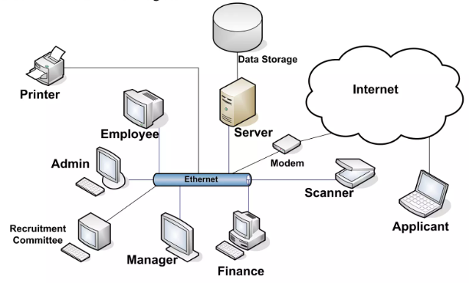

**Conclusion**

An employee management system is very important in any organization. It helps to track the performance of employees, their attendance, and how well they are doing their job.

**References**

[What is the Abstract of Employee Management System? - (worker-management.com)](https://www.worker-management.com/7-objectives-of-an-employee-management-system-abstract/)

[Employee Management System Sequence UML Diagram | FreeProjectz](https://www.freeprojectz.com/uml-diagram/employee-management-system-sequence-diagram)